Student Name: Meshal Al Bahli

Student ID: 201821447



\

Introduction:

Al Rajhi Bank is one of the oldest banks established in Saudi Arabia. Al Rajhi Bank was established in 1957 and is one of the largest banks in Saudi Arabia. The bank was started by Saleh bin Abdul Aziz Al-Rajhi and Brothers Co Provision of Islamic Financial services with exchange of money. In 1978, Formation of Al Rajhi Trading and Exchange Corporation the Religious Tourism was the thrust of the foundation of this company. In 1987, the company was transformed from a family company to a joint stock company. Al Rajhi Bank is one of the most important and largest financial companies in Saudi Arabia. Al Rajhi Bank started with a capital of SR 750 million and this amount doubled to reach SR 15 billion in 2008. In 2013, the capital was increased for the sixth time to reach SR 16250 billion. AL Rajhi Bank is the preferred bank for many Muslims around the world specially in the Kingdom because it provides banking transactions that are Compatible with Islamic Sharaaia.

Vision:
“A trusted leader delivering innovative financial solutions to enhance quality of life everywhere”. (Al Rajhi Bank)

Mission:
“To be most successful bank admired for its innovative service, people, technology and Sharia compliant products, both locally and internationally.” (Al Rajhi Bank)
The Al Rajhi Bank mission is fully committed by the organization. The company is concerned with integrity, transparency and continuous change for the better. The Bank's passion for customer service has created a strong commitment to meet all customer needs and go beyond what they expect the bank also pay a strong care of the community by participating in charitable activities.

Ownership Structure:
The General Organization for Social Insurance in Saudi Arabia owns 5.86% of the shares of Al Rajhi Bank.

SHAREHOLDERS | DESIGNATION | HOLDING PERCENTAGE AS ON TRADING DAY (%) | HOLDING PERCENTAGE FOR THE PREVIOUS TRADING DAY (%)
Abdullah Suleiman Abdulaziz Al-Rajhi | Chairman | 2.1668270 | 2.1668270
Alaa Shakeeb Murad Al-Jabri | Board of Directors | 0.0002000 | 0.0002000
Abdulaziz Khaled Ali Al-Ghafili | Board of Directors | 0.0012922 | 0.0012922
Raed Abdullah Saleh Al-Tamimi | Board of Directors | 0.0000615 | 0.0000615
Abdul Latif Ali Abdul Latif Al-Seef | Board of Directors | 0.0024615 | 0.0024615
Badr Mohammed Abdulaziz Al-Rajhi | Board of Directors | 0.0066889 | 0.0066889
Ibrahim Fahd Ibrahim Al-Ghafili | Board of Directors | 0.0066889 | 0.0066889
Salah Ali Abdullah Aba Al-Khail | Board of Directors | 0.0920000 | 0.0920000
Abdul Rahman Abdullah Abdul Rahman al-Fedy | Senior Executives | 0.0009340 | 0.0009340

Organizational Structure:
Al Rajhi Bank is managed through an administrative organization comprising six regional departments and a headquarters for public administration located in Riyadh. The bank has more than 500 branches and money transfer centers and the number are still increasing. Al Rajhi Bank's ATM network is the largest network in Saudi Arabia with over 2000 machines
(AL Rajhi Company Details Tadawul)

Significant Achievements:
Best Islamic Bank in Saudi Arabia - The Banker / 2018
Best Bank in Saudi Arabia – Euromoney / 2016 – 2017 - 2018
Best Bank in Saudi Arabia - The Banker / 2018
Best Employer Award - Employer Branding Awards / 2018
Biggest Islamic Bank - The Banker / 2018
Best Financial Institution in Saudi Arabia - Global Finance / 2018
Best Retail Bank in KSA - The Banker / 2018
Best Bank in Saudi Arabia - The Banker Award / 2017
Best Bank - The Banker Award / 2017
Best Bank in Saudi Arabia - Euromoney Award / 2017

Al Rajhi Bank achieved a profit increase of approximately 13% compared to 2017, where the profits of 2017 amounted to 9 million and 121 thousand SR. in 2018 the Bank achieved profits of 10 million and 297 thousand Saudi riyals. Total assets increased to 6.4%, while the Bank's financing assets rose to 23%.

Financial Reports:
BALANCE SHEET | 12/31/2019 | 12/31/2018 | 12/31/2017
Cash in Bank and SAMA | 39,294,099 | 43,246,043 | 48,282,471
Due from Banks | 32,058,182 | 30,808,011 | 10,709,795
Investments | 48,226,479 | 278,422,944 | 271,250,671
Loans and Advances | 249,682,805 | - | -
Fixed Assets Net | 10,407,247 | 8,897,587 | 7,858,127
Other Assets Net | 4,417,764 | 3,629,245 | 5,015,464
Trading Securities | - | - | -
Total Assets | 384,086,576 | 365,003,830 | 343,116,528
Due to Banks | 2,219,604 | 7,289,624 | 5,522,567
Customer Deposits | 312,405,823 | 293,909,125 | 273,056,445
Other Liabilities | 18,269,492 | 15,251,063 | 8,786,598
Total Liabilities | 332,894,919 | 316,449,812 | 287,365,610
Share Capital | 25,000,000 | 16,250,000 | 16,250,000
General Reserves | -216,041 | -349,555 | 5,281,682
Statutary Reserves | 21,789,632 | 16,250,000 | 16,250,000
Retained Earnings | 4,618,066 | 16,403,573 | 17,969,236
Fair Value/Cash Flow Hedges Adj Act | - | - | -
Shareholders’ Equity | 51,191,657 | 48,554,018 | 55,750,918
Total Liabilities and Shareholder Equity | 384,086,576 | 365,003,830 | 343,116,528
Contra Accounts | - | - | 13,765,837
Last Update Date | 2/19/2020 | 2/11/2019 | 2/18/2018

(AL Rajhi Company Details Tadawul)

INCOME STATEMENT | 12/31/2019 | 12/31/2018 | 12/31/2017
Fees from Services | 1,987,367 | 3,101,286 | 2,697,208
Exchange Income | 774,096 | 755,804 | 841,839
Trading Income | - | - | -
Realized Gains on Investments, net | 16,427,723 | 13,252,733 | 12,029,417
Dividend Income | - | - | -
Other Operating Income | 295,278 | 209,695 | 336,390
Total Operating Income | 19,484,464 | 17,319,518 | 15,904,854
Salaries and Employees Benefits | 2,794,046 | 2,809,449 | 2,813,918
Rent and Premises | - | 314,567 | 311,015
Depreciation | 1,059,582 | 442,171 | 440,566
Other General and Admin Expenses | 2,532,213 | 1,925,518 | 1,671,052
Provision for Credit Losses | 1,772,265 | 1,530,946 | 1,547,577
Total Operating Expenses | 8,158,106 | 7,022,651 | 6,784,128
Extraordinary item | -1,167,831 | - | -
Net Income from Operations | 10,158,527 | 10,296,867 | 9,120,726
Balance at Beginning of Period | 12,499,171 | - | -
Transferred to Reserves | -5,539,632 | - | -
Cash Dividend | -3,750,000 | - | -
Other Distributions | -2,341,473 | - | -
Balance at End of Period | 868,066 | - | -
Last Update Date | 2/19/2020 | 2/11/2019 | 2/18/2018

(AL Rajhi Company Details Tadawul)

CASH FLOW | 12/31/2019 | 12/31/2018 | 12/31/2017
Net Income | 11,326,358 | 10,296,867 | 9,120,726
Depreciation | 1,076,803 | 458,587 | 457,428
Gain/Loss on Sale of Fixed Assets | -568 | 115 | -594
Provision for Possible Credit Loss | 1,772,265 | 1,530,946 | 1,547,577
Due from Banks | -3,174,273 | -15,005,538 | 8,083,181
Trading Securities | - | - | -
Loans and Advances | -19,696,863 | -4,940,851 | -10,089,026
Other Assets | -2,043,327 | -68,984 | -919,759
Due to Banks | -5,070,020 | 1,767,057 | -3,394,403
Deposits | 18,496,698 | 20,852,681 | 463,309
Other Liabilities | 4,388,757 | -520,389 | 2,293,735
Net Cash Used in Operations | 7,075,830 | 14,370,491 | 7,562,174
Purchase of Investment | -3,658,476 | -6,800,647 | -2,196,031
Purchases of Fixed Assets | -1,527,133 | -1,481,746 | -1,813,962
Net Cash from Investing Activities | -5,185,609 | -8,282,393 | -4,009,993
Dividend Paid | -10,565,325 | -7,523,790 | -5,013,971
Cash Used for Financing Activities | -10,565,325 | -7,523,790 | -5,013,971
Net Changes in Cash and SAMA | -8,675,104 | -1,435,692 | -1,461,790
Cash and Balances with SAMA Beg. Year | 29,786,503 | 31,222,195 | 32,683,985
Cash and Balances with SAMA End Year | 21,111,399 | 29,786,503 | 31,222,195
Last Update Date | 2/19/2020 | 2/11/2019 | 2/18/2018

(AL Rajhi Company Details Tadawu
Summary of balance sheet:
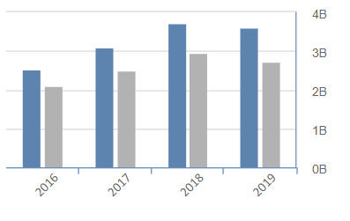
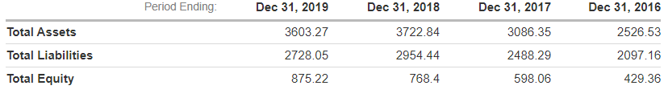
Summary of income statement:
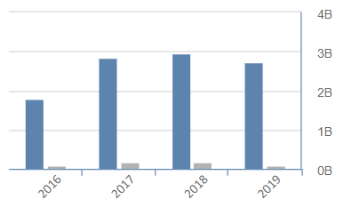
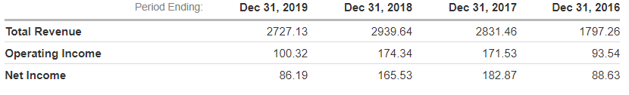
Summary on cash flow statement:
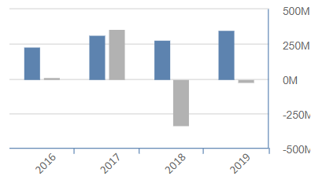
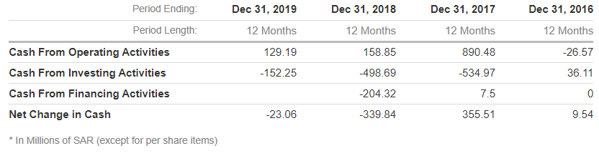

Ratio Analysis:

Solvency Ratio
Ratio | Formula | 2019 | 2018 | 2017
Debt to capital ratio | Total debt / Total debt + Total equity
Debt to asset ratio | Total dept / Total Assets
Debt to equity ratio | Total dept / Total equity
Financial leverage ratio | Average total assets / Total shareholders’ equity

Efficiency ratios
Ratio | Formula | 2019 | 2018 | 2017
Asset turnover | Net Sales / Total Assets
Stock turnover | Cost of goods sold / average inventory
Collection period | Average accounts receivables / Average daily sales
Receivables turnover | Total sales / average accounts receivables
Operating expense ratio | Total expenses / Gross revenues
Depreciation expense | Depreciation expense / Gross revenue
Interest expense | Total interest expense / Gross revenue

Profitability ratios
Ratio | Formula | 2019 | 2018 | 2017
Current ratio | Current assets / Current liabilities
Cash ratio | Cash / Current liabilities
Return on assets | Net income / Total assets
Return on capital | EBIT / TA - CL
Net profit margin | Net income / Total sales
Return on equity | Net income / Equity

WACC
WAAC = (E/V) × Re + (D/V) × (1-Tax rate) + Cost of preferred stock × % preferred stock.

Dividend Information:

Conclusion:

References:
https://www.tadawul.com.sa
https://www.investing.com/equities/alabdullatif
https://www.alrajhibank.com.sa/

